

Chapter 6

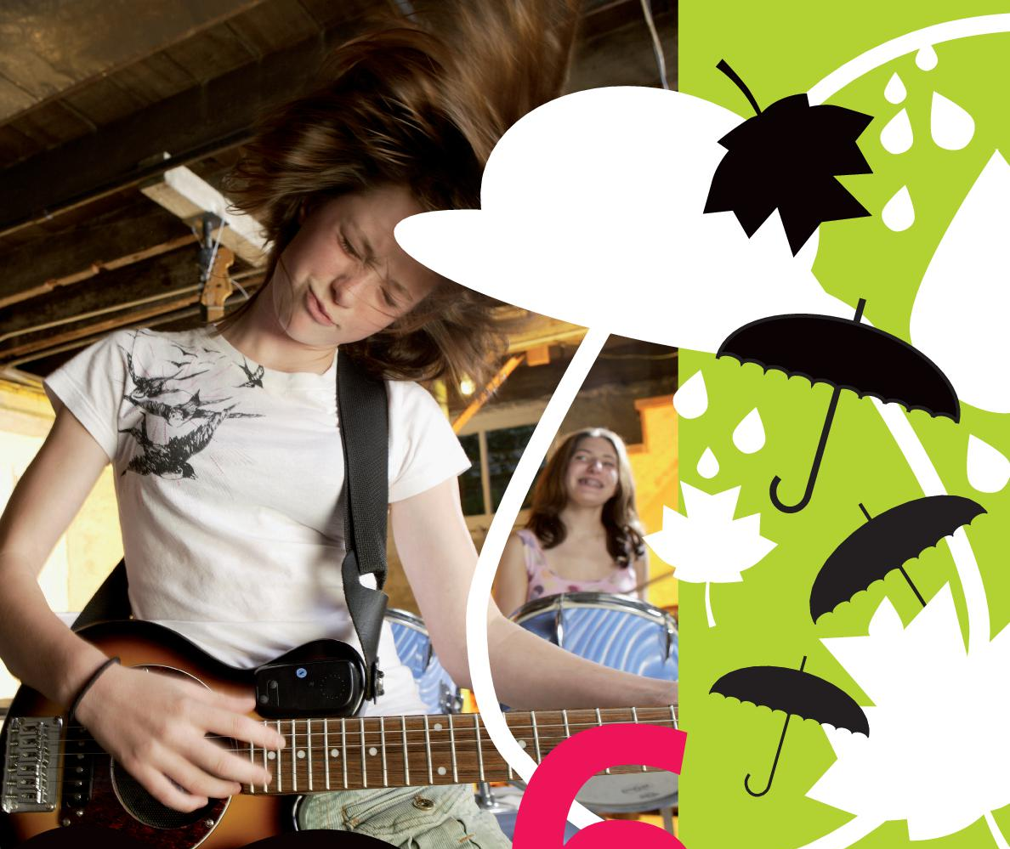

Grammar Trainer

Adjectives & adverbs – Bijvoeglijke naamwoorden en bijwoorden

1. Fill in ◊
Vul de juiste vorm in van de woorden tussen haakjes.

- She sings (beautiful)__________.
- The children are playing (happy) __________.
- My dad always drives too (fast) in his car__________.
- You play the piano (good) __________.
- He was shouting (terrible) __________.
- She can play the drums (wonderful) __________.

2. Cross out ◊◊
Cross out what’s wrong
Lees het onderstaande dagboekfragment en streep door wat fout is.
Dear diary,
Yipee, I did it! I, Nigella Harriot, have won this year’s BBC Junior Master Chef competition. I’ve always known I’m a [1] wonderful / wonderfully chef. The dishes I make are simply [2] delicious / deliciously. The other two contestants prepared their dishes [3] good / well too. But mine were simply the best. For starters I served a [4] nice / nicely tomato soup with fresh basil and [5] crispy / crispyly / crispily oregano croutons. I cut them [6] beautiful / beautifully in the shape of little stars. I didn’t really have much time for the main course, so I made a [7] basic / basicly / basically but very refined meal. It was a gorgonzola lasagna with carrots and herbs. I worked very [8] careful / carefully for half an hour and then put it in the oven. With my lasagna in the oven, I took my time to make a [9] tasty / tastily desert: a chocolate, banana, vanilla and hazelnut milkshake. Then my time was almost up, so I [10] quick / quickly set the table. The jury members tasted all the dishes by taking one bite from each course and decided I was the winner. My prize is a two-week cooking holiday in Paris with one of the best chefs in the world. Isn’t that [11] fantastic / fantastically?

3. Cross out ◊◊
Cross out what’s wrong
Streep de foute vorm van de woorden tussen haakjes door en zet de juiste vorm in de briefkaart. Kies steeds uit het bijvoeglijke naamwoord en het bijwoord.
Hi Annie,
Just a few words from [1] (beautiful / beautifully) Scotland. It’s a [2] (fantastic / fantastically) country, but I’m constantly cold ! We’ve seen a lot of [3] (wonderful / wonderfully) things and everything is going [4] (good / well). Yesterday we went to a [5] (noisy / noisily) party – all the men wore [6] (colourful / colourfully) skirts! They looked [7] (awful / awfully). My aunt is a [8] (good / well) cook, but yesterday I had to eat a [9] (horrible / horribly) dish – it’s called haggis and you don’t want to know what’s in it! Dancing was [10] (nice / nicely), though. I have a lot of [11] (interesting / interestingly) cousins and they all dance [12] (fantastic / fantastically). So, you see – I’m having a [13] (terrific / terrifically) time! Despite the fact that it is raining [14] (heavy / heavily) at the moment. Love, Mary Jo

4. Fill in ◊◊◊
Fill in the correct forms

>Why are you laughing so [1]__________ (loud).
<Someone told me a really [2]__________ (funny) story.
>Let’s hear it then. I always like a [3]__________ (good) story.
<You know that Sarah is always acting so [4]__________ (childish), don’t you?
>Yes, she always behaves [5]__________ (stupid). Well, yesterday she did it again. You see, Melanie sings really [6]__________ (good) and Sarah can’t stand it. So while Melanie was singing, Sarah started yelling really [7]__________ (hard). Melanie’s dog didn’t like that though. Melanie’s got a [8]__________ (huge) dog, you know. He came after Sarah. Sarah had to run away really [9]__________ (fast). You should have seen her. She was so scared. It was really funny.
<I wish I’d been there to see Melanie’s face. That must have been a [10]__________ (fantastic) thing to see.

5. Fill in ◊◊◊
Fill in the right form
Read this diary entry. Indicate whether the words in italics are correct or should be changed.

12 August 2006
Dear diary,

Today was a [1]__________ (strange) day. It started rather [2]__________ (good). I met Jenny in the school canteen. She was smiling at me, with her [3]__________ (beautiful) smile. Oh, she is so [4]__________ (pretty). After our break we went to Mr Jones’s lesson. He teaches English [5]__________ (awful). 45 minutes of English grammar is [6]__________ (terrible)! When our lessons were finally over, we got to the school bus. Usually the bus ride is [7]__________ (short), but this time it lasted far too long. Let me explain; I was standing on the school bus because there were no seats left. Then the busdriver suddenly hit the brakes very [8]__________ (hard) Before I knew it I was flying through the air down to the front of the bus. I landed on my face. I was hurting [9]__________ (terrible)all over. I stood up, but I slipped on the wet surface and fell straight back down again. Then I grabbed something to pull myself up with, and let go [10]__________ (immediate)because it was
some girl’s breast. I was so embarrassed that I got off the bus at the next stop and walked the rest of the way home!

6. Write down ◊◊◊
Write down the correct form
Vul de juiste vorm van de woorden tussen haakjes in. Kies uit bijwoord of bijvoeglijk naamwoord.

Yesterday we were supposed to have a barbecue, but unfortunately it rained [1]__________ (horrible). That’s why we decided to have a barbecue today. Right now, the meat is on the grill and it smells [2]__________ (terrible) [3]__________ (good). My brother has prepared it. He can cook [4]__________ (extreme) [5]__________ (good). The only problem is that he always wants to cook too [6]__________ (fast). And then the meal gets burned and it smells [7]__________ (awful). And he always wants to try new recipes with ingredients that are [8]__________ (remarkable) [9]__________ (hard) to find. My mother on the other hand is an [10]__________ (incredible) [11]__________ (terrible) cook. Whenever she makes our dinner it tastes [12]__________ (horrible). I think she can [13]__________ (easy) do better, but she’s just lazy!

Degrees of comparison – Trappen van vergelijking

1. Fill in ◊
Fill in
Vul de overtreffende trap in. Gebruik de woorden tussen haakjes.
Voorbeeld: Tim is our smartest student. (smart)

- I’m going to the []__________ party in town. (cool)
- They work in the []__________ office in town. (big)
- This is the []__________ pupil from class 1 C. (smart)
- We live in the []__________ house in the street. (nice)
- This is the []__________ trip of the year. (long)
- You are the []__________ pupils I know. (happy)
- What is the []__________ way to learn English. (easy)
- I’m in love with the []__________ popstar in Britain. (beautiful)
- He can do the []__________ exercise in the book. (difficult)
- This is the []__________ lasagne in the world. (good)

2. Fill in ◊◊
Fill in. Vul de vergrotende trap in. Gebruik de woordjes tussen haakjes.
Voorbeeld: My brother is taller than my friend. (tall)

- This dog is []__________ than your dog. (small)
- Magazines are []__________ than books. (cheap)
- This man is really fat, but my uncle is []__________. (fat)
- Open the door []__________,I can’t see you. (wide)
- Teachers must be []__________, I think. (strict)
- I have a []__________ piece of cake than Peter. (big)
- I like this book, it’s []__________ than that book. (funny)
- When you’re number one you will be []__________ than when you’re number two. (happy)
- This story is []__________ than yours. (interesting)
- Madonna is []__________ than Britney Spears. (popular)
- The patient is feeling []__________ today. (good)
- Yesterday the weather was []__________.(bad)

3. Fill in ◊◊
Fill in
Vul de juiste vorm van de woorden tussen haakjes in. Gebruik de trappen van vergelijking.

Dear Diary,
Today was the [1]__________ (good) day of my life! Let me tell you what happened. I got up at 6.30 am. I never got up any [2]__________ (early) than that. When I came downstairs Mum had prepared the [3]__________ (big) breakfast ever! My plate was full, but my brother’s plate was even [4]__________ (full). I had a large glass of orange juice, but Dad had an even [5]__________ (large) one. Then we all went to this theme park, Six Flags Holland. There we saw the [6]__________ (beautiful) roller coasters in the world, but also the [7]__________ (scary)! I think it was very interesting watching all these people get into these scary things. What I found [8]__________ (interesting), though, was that all these people were even [9]__________ (afraid) than I was. Anyway, in the end I really liked all the roller coasters, but the one I liked [10]__________ (good) was Superman The Ride. This was by far the [11]__________ (fast) ,[12]__________ (high), [13]__________ (funny) and [14]__________ (expensive) of them all. Do you know what the [15]__________ (nice) thing was: not knowing that we were going in the first place. Well, I’m exhausted, so I’m going to bed now!

4. Fill in ◊◊◊
Fill in

Example: My mother is very happy.
My sister is even happier.
I’m the happiest of all.

- This car is very big.
That car is even (a) __________.
This car is the (b) __________ of all three.

- My room is quite (a) __________.
Susan’s room is a lot smaller.
Eric’s room is the (b) __________ of all.

- This book is very interesting.
The book my father is reading is even (a) __________
This is the (b) __________ book I have ever read.

- My mother’s soup tastes very (a) __________
My aunt’s soup tastes even (b) __________
The soup my grandmother makes tastes best.

- The weather today was very (a) __________
Yesterday the weather was even worse.
Last week we had the (b) __________ storm ever.

5. Fill in and write down ◊◊◊
Fill in and write down sentences
Fill in the missing words in the grid and write a sentence with the given word.
Example: happy happier happiest
She laughs a lot and is always very happy.

1 |  | bigger
2 |  |  | smallest
3 | interesting
4 |  | better
5 | bad

6. Fill in ◊◊◊
Jamie from Great Britain is talking to Jessica from the Netherlands about school. Fill in the correct words.
Sometimes you have to fill in other words besides the degrees of comparison to complete the sentence.

Jamie: Do you learn English at school?
Jessica: Of course I do. I think it’s [1]__________ subject there is. (awful)
Jamie: Really? I think English is great, even [2]__________ PE. (great) Why do you hate English so much?
Jessica: I guess it’s just because I’m not very good at it. My marks for English are even [3]__________ my marks for maths. (bad)
Jamie: What’s your English teacher like?
Jessica: Oh, she [4]__________ teacher at school. (nice) And she’s also [5]__________ (funny). Why are you wearing a uniform?
Jamie: We have to wear uniforms to school. I like my uniform, but I think that being allowed to wear your own clothes to school would be [6]__________ . (good)
Jessica: Well, I think your uniform looks smashing. It looks even [7]__________ the outfit I’m wearing today. (smashing) What are you going to do this afternoon?
Jamie: I think I’m going to cheer up my little brother. At the moment he’s [8]__________ boy I know. (sad)
Jessica: Why’s that?
Jamie: He has a really bad school report. That’s why he’s not allowed to play football for a month. That’s [9]__________ punishment my parents could give him. (hard)

